**Project Report**

# Introduction:

## 1.1 Project overview:

Covid has shown us how vastly unprepared we are at monitoring aspects of various infectious diseases that are at our door. Diseases will always be present in our world and it is our job to harness the power of technology to more effectively maintain and monitor their effects on society. The Covid-19 pandemic has brought forth an immediate requirement for effectively creating and monitoring containment zones or isolation zones that are specific places where people are not allowed to move freely in order to curb the spread of the pathogen. Throughout history many other diseases have required the use of isolation to prevent their spread but none have been as virulent as the coronavirus pathogen.

The pathogen has proven to be quite effective at spreading to many places and rapidly. The immediate calls for isolation and quarantine have been met with wide areas of confusion and disconnect where governmental organizations and medical groups were unable to effectively deploy or monitor the containment or quarantine zones. And this brings us to the project which aims to create and monitor the containment zones in the cloud to more effectively maintain the zones and to add new zones with more ease and to help people check their nearest zones so that they can avoid the unfortunate case that they have to visit a coronavirus hotbed or heavy infection zones.

## 1.2 Purpose:

It is important to fix this problem because nothing is more important than human welfare. If this problem keeps on increasing then a large number of people will suffer from the disease and thus it will affect society in all aspects. Delay in solving this problem will worsen the situation of the world very much and it will take a lot of time to recover from its effects.The project aims at building an application that provides information about the containment zones of a particular region by continuously monitoring an individual’s location.Location of the individual must be stored in the Database. Alerts are sent using the notification service.

# Literature survey:

## 2.1 Existing problem and solution:

Survey 1:

Aarogya Setu

Aarogya Setu is a mobile application developed by the Government of India to connect essential health services with the people of India in our combined fight against COVID-19. The app is aimed at augmenting the initiatives of the Government of India, particularly the Department of Health, in proactively reaching out to and informing the users of the app regarding risks, best practices and relevant advisories pertaining to the containment of COVID-19 (Aarogya Setu 2020).

The application is developed by the government of India. It uses contact tracing technology with the help of bluetooth to check if a user comes near a Covid-19 patient.

Survey 2:

CoBuddy-Covid19 tool

CoBuddy-Covid 19 Coronavirus Help Tool-to help stop the spread of Covid 19, get info and help from the Government. The app makes sure that the people quarantined are within their location, communicate directly with them, provide information, and receive alerts if the quarantined are in need of any help. Location tracking and user verification with heat-maps, communication management, notifications and alerts, health tracking and feedback, essential operations management (CoBuddy-Covid19 tool 2020).

The application keeps track of the home quarantined Covid-19 patients and their needs by the concerned authorities.

Survey 3:

CORONTINE

This app is designed to help organisations (including the Government of Meghalaya) to maintain accountability and responsibility towards members and society. The app accomplishes this by monitoring the geographical movements of members and ensuring they are following proper work from home protocol and social distancing policies set by the organisation. Data will not be used for any purpose other than the safety of the members. Members have the right to activate/inactivate location as per their discretion. This app sends coordinates to the server if the user activates location. Users can check in at their home location and will be alerted if they leave the region around home location. Administrator/support cell will also get the list of users who are within the circle or outside the circle. Only authorized admin can access the backend services for the purpose of safety of registered users. App provides an option for the user to recheck in at a new location with the approval from administrator/Unit manager via OTP. App provides more information like emergency contact numbers and similar important information for the users to access in a short time at the hour of need (CORONTINE 2020).

The application provides questionnaire based self-diagnosis, general symptoms and precautionary tips related to Covid-19. It sends alerts to the concerned authorities if the person under home quarantine leaves the location around their home.

Survey 4:

SAIYAM-track and trace together

With the help of Saiyam we can together create an environment of safety and security (SAIYAM-track and trace together 2020).

This application is not directly related to Covid-19. It provides self-restraint to the user during lockdown.

Survey 5:

Prayagraj COVID19 hotspots

With the approval of administration, the COVID19 hotspots data are being collected to serve the community. An initiative from Data Live Technology.

Only the app is published by Facewhiz Technologies (Prayagraj COVID19 hotspots 2020) The application could not be operated.

## 

## 2.2 References:

1. <https://ieeexplore.ieee.org/document/9711880>

2. <https://ieeexplore.ieee.org/document/9432254>

3. <https://ieeexplore.ieee.org/document/9356316>

4. <https://ieeexplore.ieee.org/document/9388625>

5. <https://ieeexplore.ieee.org/document/9609407>

6. <https://ieeexplore.ieee.org/document/9356316>

## 2.3 Problem statement definition:

With COVID-19 alarming surge of affected cases throughout the world, lockdown and awareness (social distancing, use of masks, etc) among people are found to be the only means of restricting community transmission. In a densely populated country like India, it is very difficult to prevent community transmission even during lockdown without social awareness and precautionary measures taken by the people. Recently, several containment zones had been identified throughout the country and divided into red, orange, and green zones, respectively. It will be helpful to safeguard the people if we have some application that will tell us about the condition of the locality regarding COVID.

| Question | Description |
| --- | --- |
| Whom does the problem affect? | All the human beings |
| What are the boundaries of the problem? | Geographic, count of patients, GPS |
| What is the issue? | COVID has spread worldwide and has disrupted global trade, employment, and travel. This COVID has affected a lot of people emotionally, mentally, and economically. Even after a lot of vaccines campaign and safety measures, people are getting infected by COVID as they unknowingly enter COVID hotspots which makes them prone to the disease |
| When does this issue occur? | The issue occurred during the corona pandemic |
| Where is the issue occurring? | The issue occurs when people try to move freely outside the house without taking necessary safety measures and without proper vaccines |

| Why is it important that we fix this problem? | It is important to fix this problem because nothing is more important than human welfare. If this problem keeps on increasing then a large number of people will suffer from the disease and thus it will affect society in all aspects. Delay in solving this problem will worsen the situation of the world very much and it will take a lot of time to recover from its effects |
| --- | --- |

# Ideation & proposed solution:

## 3.1 Empathy map canvas:

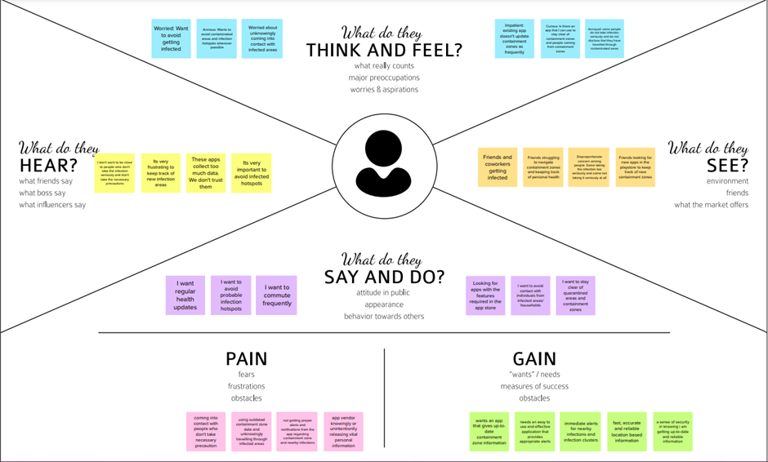

## 3.2 Ideation & brainstorming:

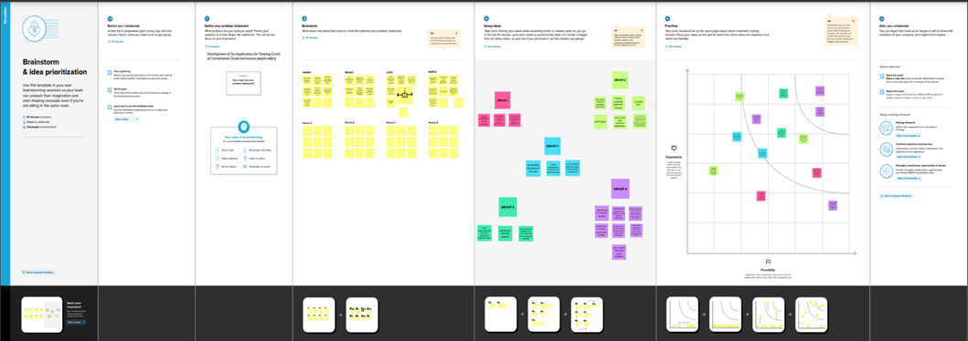

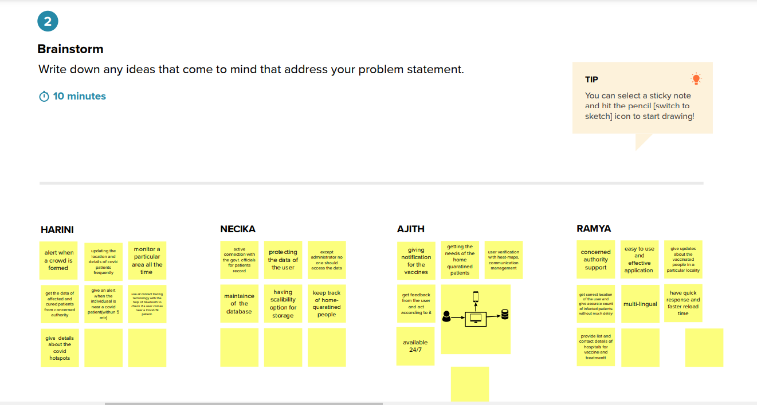

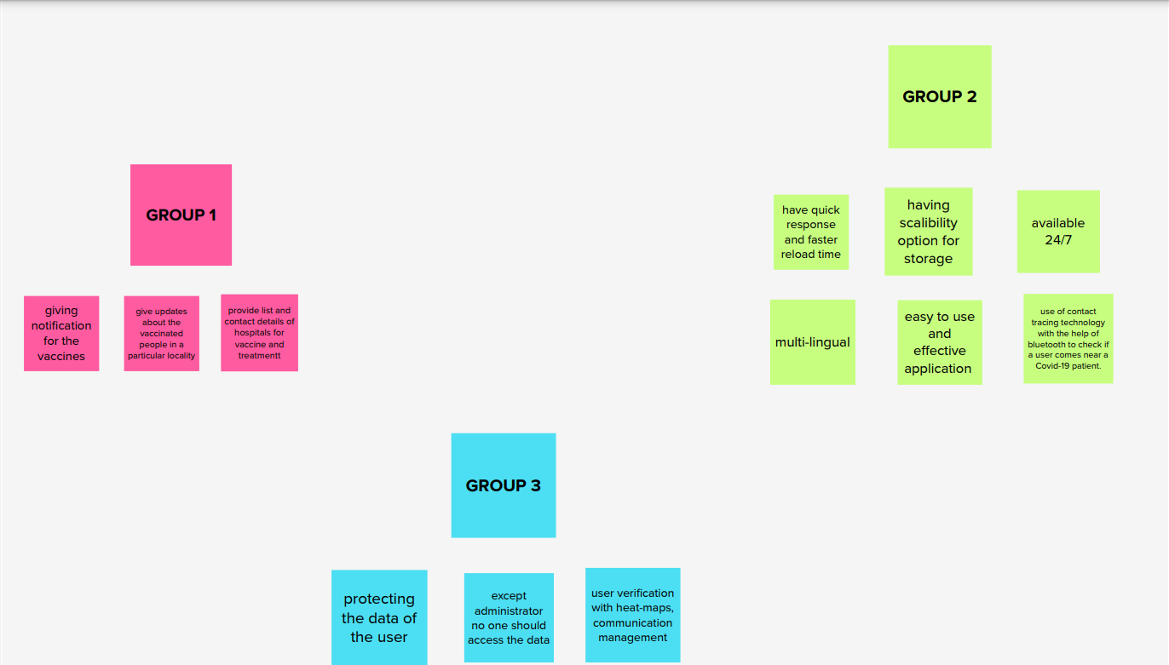

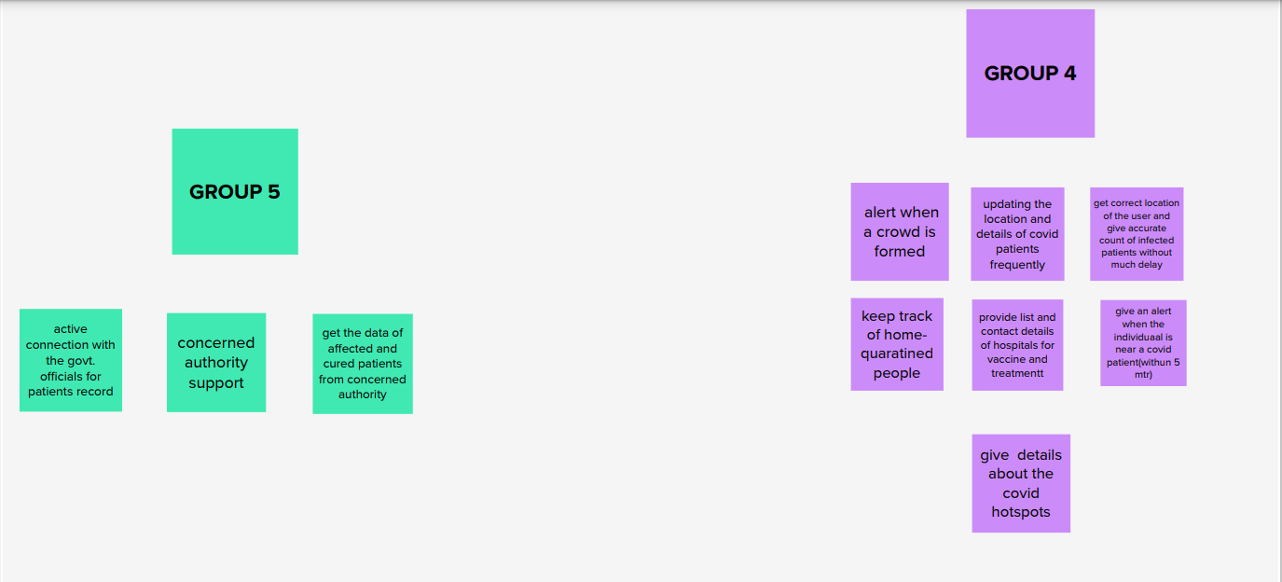

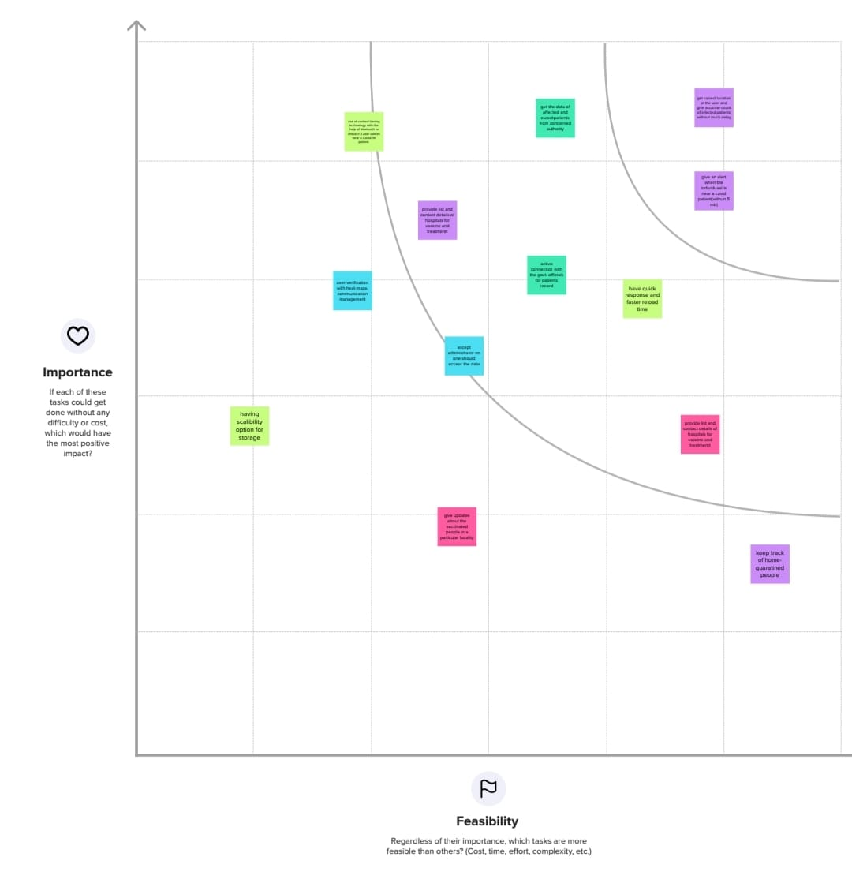

## 3.3 Proposed solution:

| S.No. | Parameter | Description |
| --- | --- | --- |
| 1. | Problem Statement (Problem to be solved) | To Provide information about the containment zones in a particular region by alerting the people trespassing the region through continuous monitoring of their location. |
| 2. | Idea / Solution description | The project aims at building an application that provides information about the containment zones of a particular region by continuously monitoring an individual’s location.Location of the individual must be stored in the Database. Alerts are sent using the notification service. |
| 3. | Novelty / Uniqueness | The uniqueness of containment zone alerting app is it shows the particular area of the place in a certain distance , and the user's location history is stored in database and this app provides the precautions measurements, list of immunity  boosters, location of the vaccination providing places nearby. |
| 4. | Social Impact / Customer Satisfaction | Social Stigma is discrimination against a particular group of people, a place, or a nation in the form of a negative  attitude.Public health emergencies (such as COVID-19 pandemic) are stressful situations for people and communities. Fear and anxiety with a lack of knowledge about the disease can lead to social stigma. The containment zone alerting app users are 100% satisfied because of its immediate notification of a particular area, it provides the precautions and awareness about COVID- 19.The details provided to the users will be verified . |

| 5. | Business Model (Revenue Model) | When a user enters some other region which is not the user’s home region, the user has to subscribe in order to view the containment zones in the new region, in addition, a personal health monitoring will be provided ,zones away from the assigned zone will be visualized by subscribing. |
| --- | --- | --- |
| 6. | Scalability of the Solution | In this modern world even though the covid pandemic threat is about to end there are high chances of pandemic or endemic. So, this application is very useful in that situation and we can use this application in seasonal diseases and also as a health caring application for maintaining their health efficiently . |

## 3.4: Proposed solution fit:

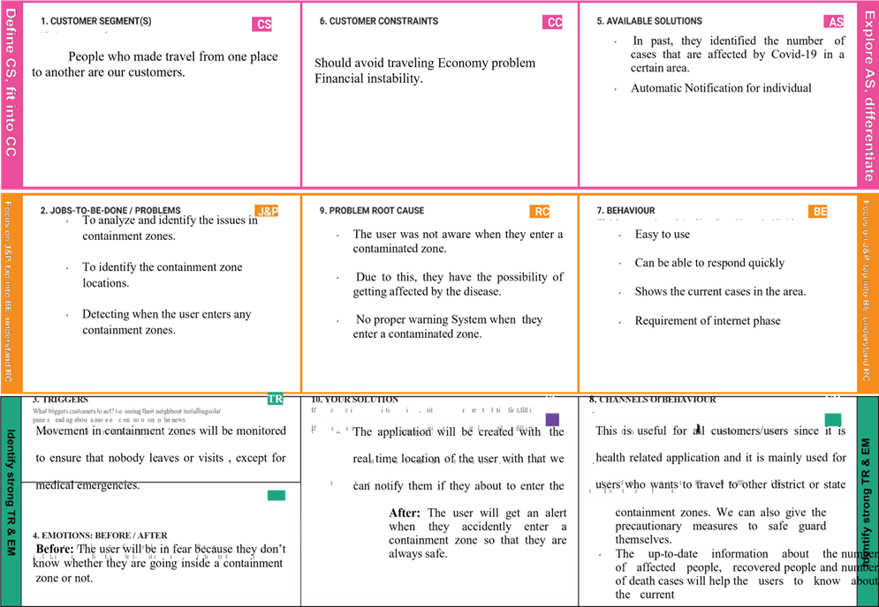

# Requirement analysis:

## 4.1 Functional requirements:

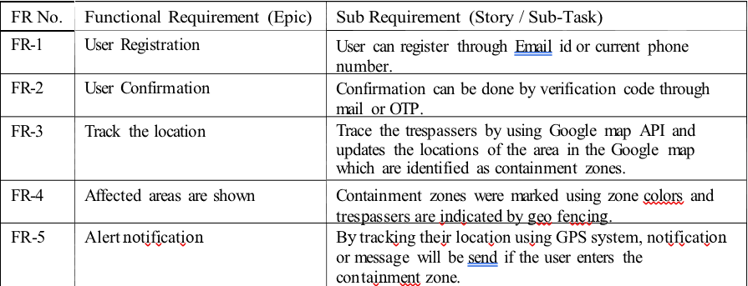

## 4.2 Non functional requirements:

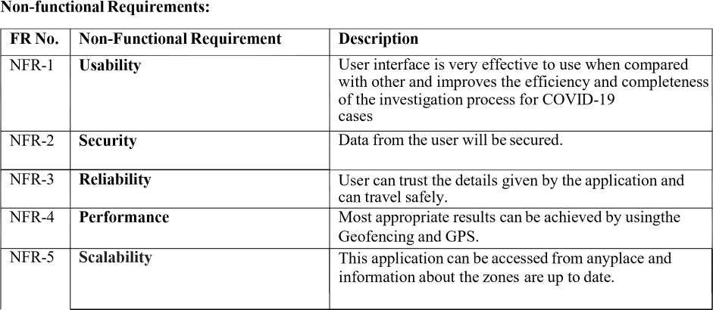

# Project design:

## 5.1 Data flow diagrams:

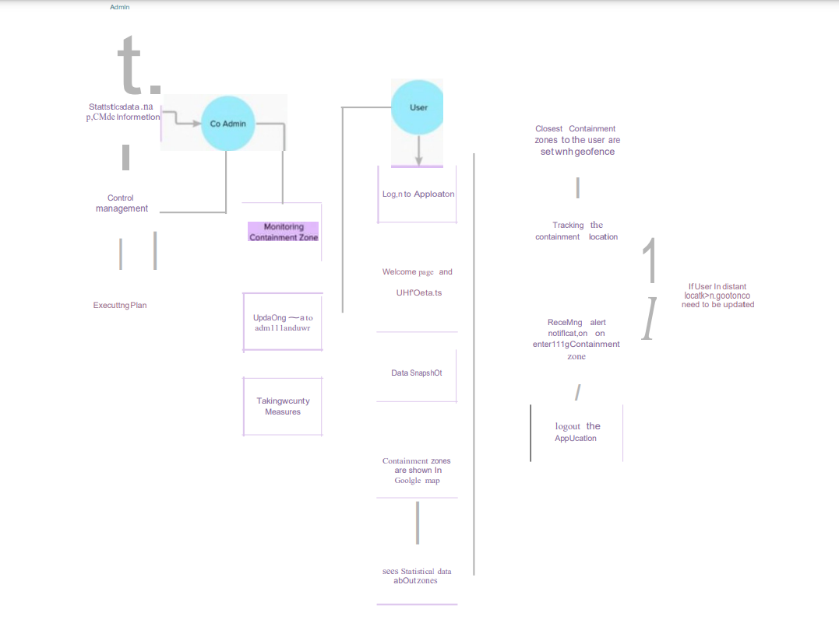

Flow:

1.The Admin control management and get statistical data of the application

2.The Co-admin monitors the Containment zone and provides updated data .

3. The User Login to their account.

4. The User can view and get more details about the containment zone and their native location.

5. Users track the containment zone by geo-fencing to get localized information and alters.

6. If a user enters a containment zone , receives an alert notification.

## 5.2 Solution and technical architecture:

The app should have a user registration and login. After the user logged into the app it will track the user's location and update the database with the current location. If the user is visiting the containment zone he will get an alert notification through sendgrid .The users data will be stored in a safer way to make sure it wasn’t misused.

They should login to the app and update the containment zones locations in the portal. Based on the location a Geofence will be created within a 100 meters radius. They should be able to see how many people are visiting that zone.

The users can send their feedback about their experience and issues if they faced it through IBM watson and some other chat-bot services will be implemented for user convenience .

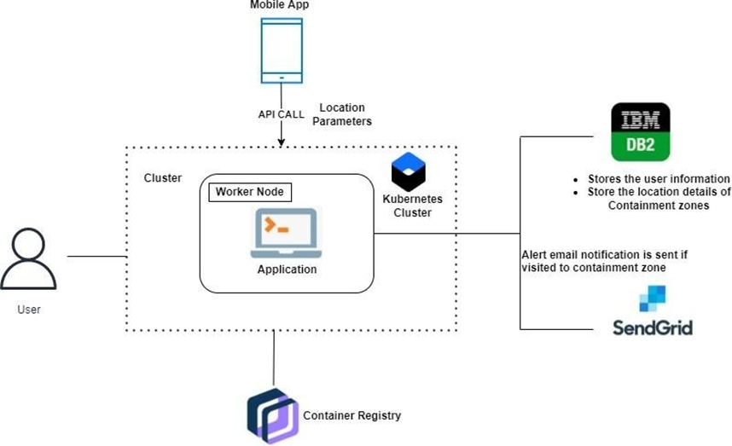

## 

## 5.3 User stories:

| User Type | Functional Requireme nt(Epic) | User  Story  Num  ber | User Story / Task | Acceptance criteria | Priority | Priority |
| --- | --- | --- | --- | --- | --- | --- |
| Administrator | Login | USN-1 | Get the statistical data | I can manage web  account/  dashboard | High | Sprint-2 |
|  |  | USN-2 | Control  Management | I can manage the Containment zones | Medium | Sprint-1 |
|  |  | USN-3 | Executing plan | I can execute plan and process the database. | High | Sprint-1 |
| Co  Administrator | Login | USN-4 | Monitor the zones and updates the data to admin and user | I can manage Containment zone monitoring and updating data | High | Sprint-1 |
|  |  | USN-5 | Taking security measures | I can take security measures on requirement | Medium | Sprint-2 |
| User | Login /Sign-Up | USN-6 | Receiving welcome message and  data snapshots | I can Get information about zones and analyzing | High | Sprint-1 |
|  |  | USN-7 | Showing    Containment zones in map | I can track the zones and find containment zones and  Medical places. | High | Sprint-1 |
|  |  | USN-8 | Receiving alerts and  Notifications | I can receive alert  notification while entering containment zones | High | Sprint-1 |

# Project planning and scheduling:

## 6.1 Sprint planning & estimation:

| Sprint | Functional Requirement  (Epic) | User Story  Number | User Story / Task | Story Points | Priority | Team Members |
| --- | --- | --- | --- | --- | --- | --- |
| Sprint-1 | Registration | USN-1 | User: I can register for the application by entering my email, password and verifying  password | 3 | High | AJITH  RAMYA  NECIKA |
| USN-2 | User: I will receive a confirmation email once I have registered for the  application | 2 | High | AJITH  RAMYA  HARINI |
| USN-3 | User: I can register for the application through  Gmail | 5 | Mediu m | RAMYA  NECIKA |
| USN-4 | Management: I need to register my hospitals on  the site. | 2 | High | NECIKA  HARINI |
| Login | USN-5 | User: I can log into the application by entering  my email & password | 3 | High | AJITH  RAMYA |
| USN-6 | Management: I need to login into my dashboard with my given hospital id  and password. | 5 | Mediu m | AJITH  HARINI |
| Sprint-2 | Dashboard | USN-7 | User: I need to give permission to access my Contacts, Location, and  Storage | 5 | High | AJITH  RAMYA  NECIKA  HARINI |

|  |  | USN-8 | User: I get access to the dashboard which shows a map with containment  zones | 5 | High | AJITH  RAMYA  NECIKA  HARINI |
| --- | --- | --- | --- | --- | --- | --- |
| USN-9 | Management: I need to enter the case information of the patient that visits our  hospital. | 5 | High | AJITH  RAMYA  NECIKA  HARINI |
| Service | USN-10 | Admin: I need to provide valid information about  the pandemic out there. | 5 | High | AJITH  RAMYA |
| Sprint-3 | Dashboard | USN-11 | Management: I need to store all the patient  information on the cloud. | 5 | High | AJITH  HARINI |
| Service | USN-12 | Admin: I need to provide medical advice through a  chatbot. | 5 | Mediu m | NECIKA  HARINI |
| USN-13 | Admin: I need to provide medical recommendations by collaborating with top  hospitals | 5 | Low | AJITH  NECIKA |
| USN-14 | Admin: I need to provide preventive measures when they travel through  it. | 5 | High | RAMYA  NECIKA |
| Sprint-4 | Register | USN-15 | User: I can register for the application through  Facebook. | 2 | Low | AJITH  RAMYA |
| USN-16 | User: I can register for the application through  Twitter. | 2 | Low | AJITH  HARINI |
| Service | USN-17 | Admin: I need to alert the user when they enter  pandemic zones | 3 | Mediu m | AJITH  HARINI |
| USN-18 | Admin: I need to provide special services for premium users by giving services like monitoring health by theirsmart  bands | 3 | Low | AJITH  RAMYA  NECIKA |

|  | Data Collection | USN-19 | Admin: I need to store all the user information on  the cloud | 5 | Mediu m | NECIKA  HARINI |
| --- | --- | --- | --- | --- | --- | --- |
| USN-20 | Admin: I need to collect the recent list of diseases  in the world. | 5 | Low | AJITH  RAMYA |

## 6.2 Sprint delivery schedule:

Project Tracker, Velocity & Burndown Chart:

| Sprint | Total Story Points | Duration | Sprint Start Date | Sprint End Date(Plan ned) | Story Points Completed (as on Planned  End Date) | Sprint Release Date (Actual) |
| --- | --- | --- | --- | --- | --- | --- |
| Sprint-1 | 20 | 6 Days | 24 Oct  2022 | 26 Oct  2022 | 20 | 29 Oct  2022 |
| Sprint-2 | 20 | 6 Days | 31 Oct  2022 | 05 Nov  2022 | 20 | 05 Nov  2022 |
| Sprint-3 | 20 | 6 Days | 07 Nov  2022 | 12 Nov  2022 | 20 | 12 Nov  2022 |
| Sprint-4 | 20 | 6 Days | 14 Nov  2022 | 19 Nov  2022 | 20 | 19 Nov  2022 |

Velocity:

It will be updated after the first week of work is completed. AV = Sprint duration/velocity= 20/10 = 2

## 

## 

## 6.3 Reports from JIRA:

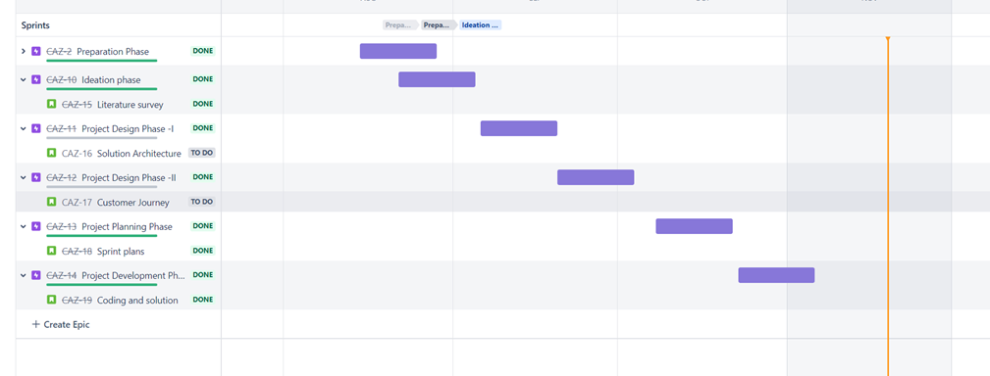

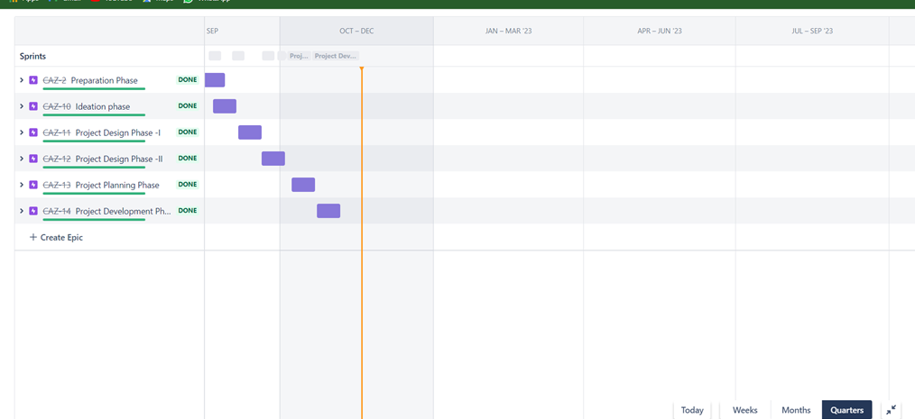

# Coding and solutioning:

## 7.1 Feature 1:

## Geofence:

Geofencing is a location-based service that sends a notification to smartphone users who enter a defined geographic area. A geofence is a virtual barrier.

Each Geofence object contains the following information:

* Latitude, longitude, and radius
* Expiration time
* Transition type
* Geofence ID

A geofence is a virtual perimeter set on a real geographic area. Combining a user position with a geofence perimeter, it is possible to know if the user is inside or outside the geofence or even if he is exiting or entering the area.

It is easier to use Google's GeofencingApi. This APIs is part of Google's Location APIs. It includes Geofence, GeofencingRequest, GeofenceApi, GeofencingEvent, and GeofenceStatusCodes. In this tutorial, we use these classes to create and work with geofences.

## 7.2 Feature 2:

Containment zone creating using API

In the current pandemic, all interventions are primarily geared towards reducing people-to-people contact, and thus breaking the chain of transmission to the extent possible.

That is the objective with which the lockdown was imposed, red, orange and green districts were classified, and containment zones were demarcated. The first two measures, which are operational at the macro level, have all but gone, due to various compulsions. The demarcation of containment zones, which works at a more micro level, is likely to remain as long as the disease is spreading. In fact, experts say this is the only practical isolation strategy available to authorities, and local administrations both in urban and rural areas need to be empowered and equipped to manage this effectively.

# 

# Testing:

## 8.1 Test cases:

A test case is a document, which has a set of test data, preconditions, expected results and postconditions, developed for a particular test scenario in order to verify compliance against a specific requirement.

Test Case acts as the starting point for the test execution, and after applying a set of input values, the application has a definitive outcome and leaves the system at some end point or also known as execution postcondition

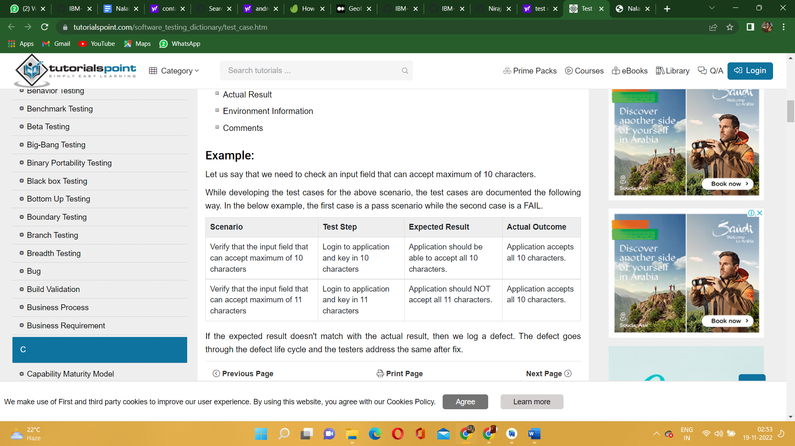

## 

## 

## 8.2 User acceptance testing:

User acceptance testing is the final testing stage in software development before production. It's used to get feedback from users who test the software and its user interface (UI). UAT is usually done manually, with users creating real-world situations and testing how the software reacts and performs.

# 

# Results:

Screenshots of mobile app UI

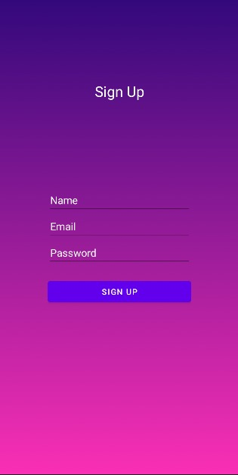

Screenshots of web app UI

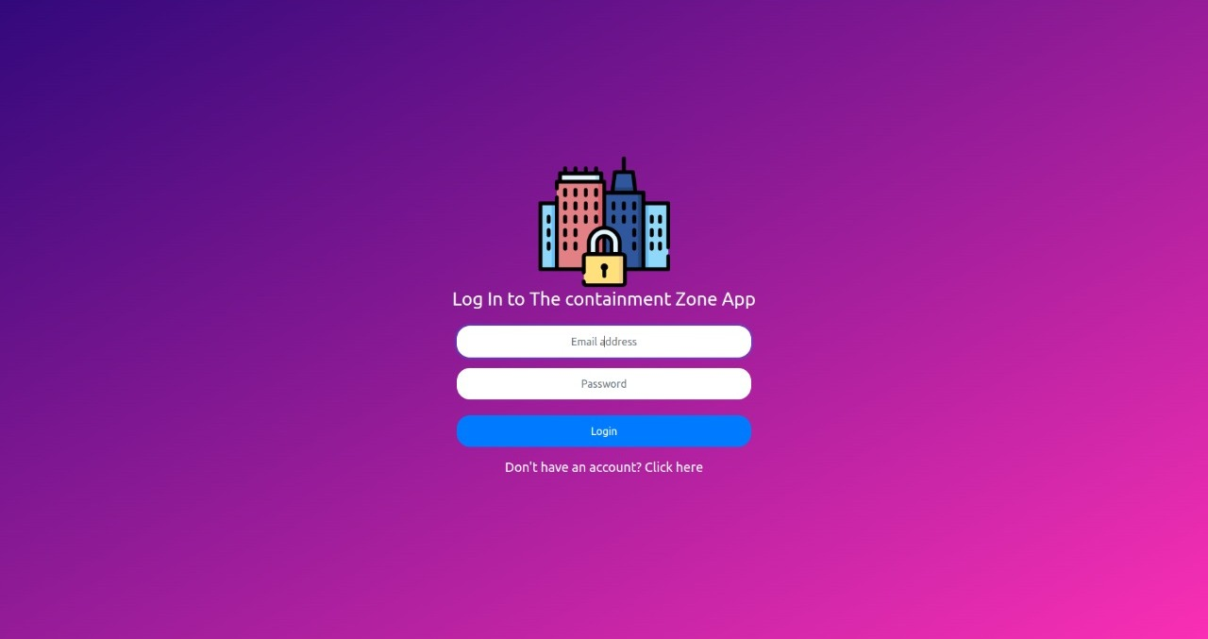

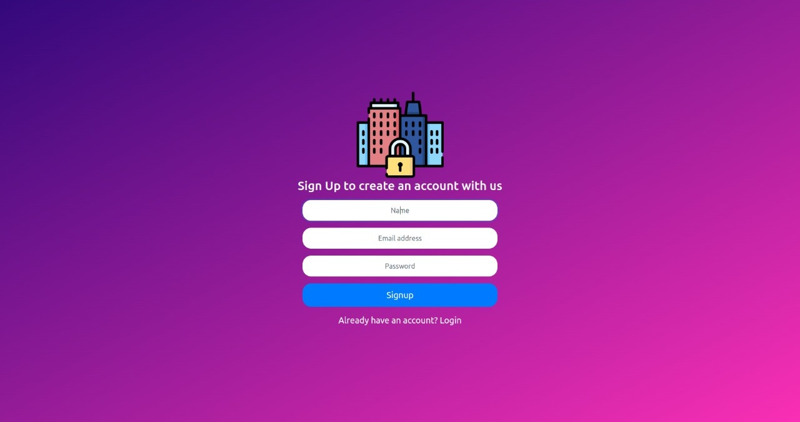

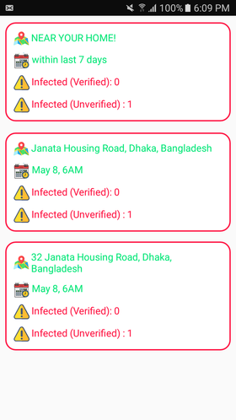 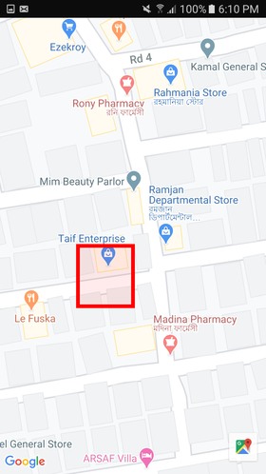

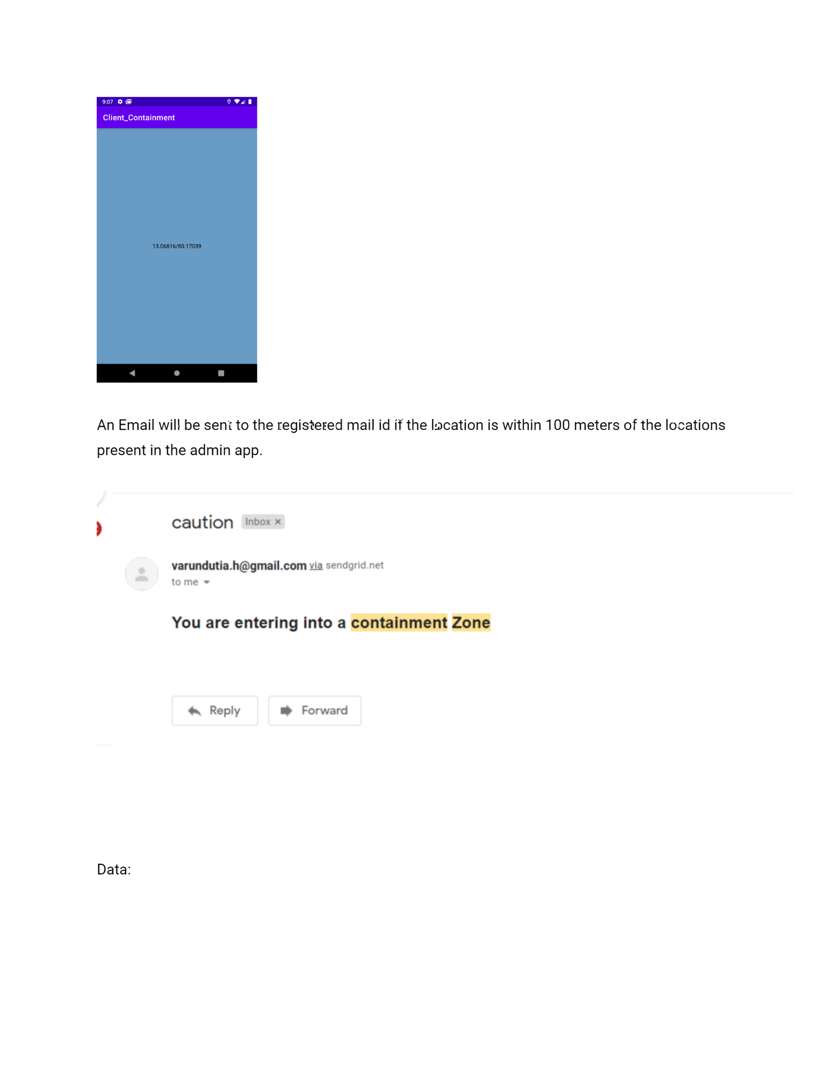

## 

## 

## 9.1 Performance Metrics:

Front-end Performance Metrics

When looked at an app’s performance from the end user’s perspective, the factors that come to mind are front-end metrics. These elements have to be worked upon on a priority basis as they are directly related to the end-user.

It includes

* Protection against app crashes
* Fit into screen
* Resource consumption
* Response time

Back-end Performance Metrics

Front-end and back-end performance metrics go hand in hand. This means some of the back-end performance elements directly influence the user’s experience and account for its UI/UX.

It includes

* Time to first byte
* HTTP request
* Connection and DNS lookups

# Advantages & disadvantages:

Advantages:

Provides safe health by alerts

Timely alert

Location based

Dynamic

Disadvantages:

Needs internet

Lack in privacy

Location dependent

# Conclusion:

The strongest and the weakest point of this App is that it is completely user based. Without a positive tested user uploading their locations or, users allowing the app to track user location or, users getting tested after being notified of probable close contact with covid positive person or, users helping relief seekers from the app’s newsfeed, functionality of this app would render useless. We have deliberately kept it this way as most other proposed apps focus on major authoritative control over monitoring users, having little or no regard for privacy.

# Future scope:

As increase in population,we suffer and experience several diseases day by day. Without consent,we are nearing and facing many people who are already with disease.So these kind of apps will help us to stay alert from suffering people,

# Appendix:

## Source code:

[Source code file](https://sendeyo.com/en/f63cbaed40)

## Github & project demo link:

# [Github link](https://github.com/IBM-EPBL/IBM-Project-24796-1659948926)